Outer Holes & Swiss Cheese CURA

Alex Aldridge, Canada 4 10, 2025  
  
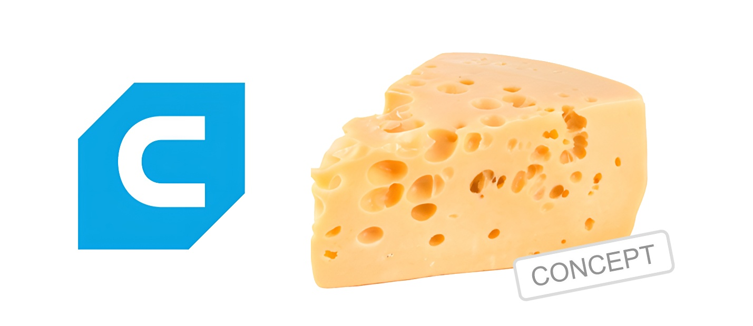

The concept behind the *Swiss Cheese Angled Hole Modifier* Python program is to introduce a novel method for integrating complex ventilation, structural, or aesthetic patterns into 3D prints. This script simulates deep, diagonal cylindrical holes — resembling the signature irregular cuts found in Swiss cheese — by removing extrusion commands along randomly generated angled paths through the G-code of a sliced model. These virtual "drill paths" are calculated to cut entirely through the model, traversing across layers and material volumes to simulate realistic tunnels or ventilation shafts. By leveraging random XY vectors and geometric distance checks, the program ensures that each selected toolpath reflects a real physical perforation. This kind of post-processing is especially valuable when aiming to lighten prints, improve airflow, or enhance the visual complexity of models without revisiting CAD design.

The underlying technique involves parsing existing G-code to locate extrusion moves and determine whether any of those moves fall within a certain radius of a randomly generated angled line. Each line acts as the central axis of a deep virtual hole, and any nearby extrusion move is replaced with a G-code comment that documents its removal. This process doesn’t merely mimic shallow or surface-level perforations — instead, it enables a print to be modified as if it were physically drilled at unpredictable yet uniform angles through the full height and breadth of the part. The implementation does not require re-slicing or altering STL geometry, making it uniquely suited as a post-processing tool that augments already prepared toolpaths.

This approach has exciting potential as a CURA plugin or extension, particularly for users of LulzBot CURA or Ultimaker CURA, where flexibility in toolpath manipulation is a critical feature.

While existing slicing engines focus on internal structure and support generation, this tool opens the door for randomized or artistic infill cuts that serve functional or creative purposes. Whether implemented as a native plugin via Python scripting within CURA’s plugin API or used externally as a command-line tool, this system could integrate seamlessly into digital fabrication workflows. It provides users with creative agency beyond the slicer's default capabilities, allowing for rapid experimentation with void distribution, material savings, and thermal properties — all without modifying the underlying mesh or requiring CAD expertise.

As a future extension, this concept could evolve to support 3D visualization overlays in CURA's Preview mode or real-time feedback showing hole impact on print time and strength. It could also support user-defined planes or patterns beyond randomness — enabling concentric cuts, honeycomb-style voids, or heat path simulations for high-performance parts. Furthermore, combining this post-processor with data-driven criteria such as mechanical stress maps or thermal zones could transform it into an intelligent optimization layer. In that sense, this "Swiss Cheese" modifier is more than a fun pattern generator — it lays the groundwork for advanced, user-controlled microstructuring in additive manufacturing, opening new avenues for customization and performance tuning.